**VISVESVARAYA TECHNOLOGICAL UNIVERSITY**

Jnana Sangama, Belgaum- 590 018



SYNOPSIS ON

### “**NIST Handwritten Pattern Recognition”**

**COMPUTER SCIENCE & ENGINEERING**

***During the Academic year 2019-20  
Submitted By***

**Name: USN:**

**Anurag G 1DB16CS023**

**C Sagar Patil 1DB16CS042**

**Harsha J K 1DB16CS056**

**Deepak S D 1DB17CS403**

Under the guidance of

**Prof. HEMALATHA M**

Designation

Dept of CSE



**Department of Computer Science and Engineering**

**Don Bosco Institute of Technology**

**Mysore Road, Kumbalgodu, Bengaluru-560074**

**CONTENTS**

* **Introduction**
* **Problem Statement & Motivation**
* **Aim & Objectives**
* **Relevance**
* **Modern Tools**
* **References**

**ABSTRACT**

Character recognition from handwritten images is of great interest in the pattern recognition research community for their good application in many areas. To implement the system, it requires two steps, viz., feature extraction followed by character recognition based on any classification algorithm. Convolutional neural network (CNN) is an excellent feature extractor and classifier. The performance of a CNN for a particular application depends on the parameters used in the network. In this article, a CNN is implemented for the NIST dataset with appropriate parameters for training and testing the system. The system provides accuracy up to 94%, which is better with respect to others. It also takes very low amount of time for training the system.

**INTRODUCTION**

Automatic handwriting recognition has a diversity of applications. It is considered as one method of communication between man and machine. Many methods were provided to handle this problem with various accuracy. The recognition method performance always depends on many attributes such as the size of the text, the writing style, and the rate of recognition. One of the main challenges of handwritten digit’s recognition is the inconsistency of the person handwriting style (i.e., width and shape), the type of device that collects the handwriting such as tablet or papers. Therefore, there is a need to have a system that can automatically recognize handwriting patterns with a high recognition rate. In the past, handwritten digit recognition with a Back-propagation Neural Network was explored. A hybrid optimization approach-based evolution strategy and gradient descent method of Bayesian classifiers were explored in. Many research results were reported for recognizing handwriting for Chinese, Arabic and Japanese characters. The recognition of handwritten Japanese characters using CNN was recently reported. By using a deep learning technique, we can reduce the number of classification errors in transcribing these handwritten digits and reduce the time taken to complete this task.

**PROBLEM STATEMENT & MOTIVATION**

Handwriting determination and recognition has been a main subject of research for more than four decade. This paper analyses the behaviour of some classification techniques in large handwriting dataset to predict the digits number. Machine-learning techniques, particularly when applied to NN, have played an increasingly important role in the design of pattern recognition systems. Several methods have been developed in hand digit detection and classified into categories: knowledge-based methods, feature-based methods, template-based methods, and appearance-based methods. Data pre-processing such as binarization is an important phase in manipulating and mining data. However, there is a lack of experimental evaluation that analyses the behaviour of such methods together. In addition, studies that deal with this aspect have ignored the part of binarization pre-processing.

**AIM & OBJECTIVES**

* The aim of the project is to recognize the words and numbers of hand-written text in images.
* Handwritten text is converted into digital format to optimize the search output.
* Also, it helps us to increase the readability of any document.

**LITERATURE SURVEY**

Image processing and Deep learning are two zones of excessive awareness to researchers and scientists around the world. It is having multiple applications fields such as robotics, medicine, and security and surveillance. Deep Learning is about learning multiple levels of representation and abstraction that help to make sense of data such as images, sound, and text. NIST data set is having a huge number of handwritten text data set and it is frequently used for training, testing, and validation of CNN deep model. In this article, we have created an efficient model with multiple convolutions, and pooling layers. Which is tested on NIST data set with 94% accuracy.

# A Multi-Layer Neural Network with one or more number of hidden units is capable of classifying the digits in NIST data set with a less than 6 % error rate on test set.

**SYSTEM ARCHITECTURE**

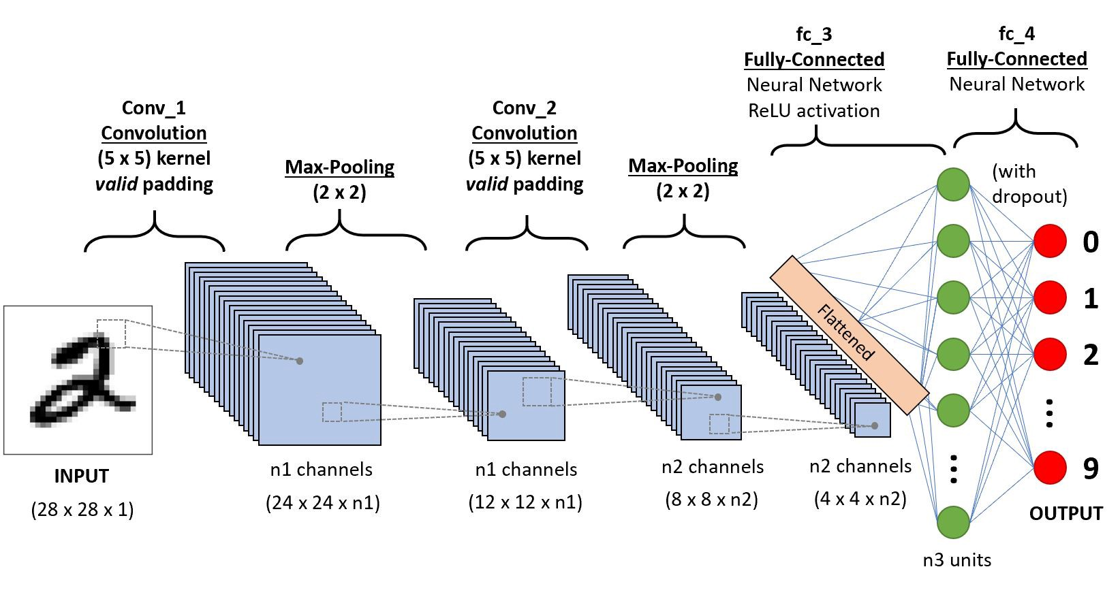

A **Convolutional Neural Network (ConvNet/CNN)** is a Deep Learning algorithm which can take in an input image, assign importance (learnable weights and biases) to various aspects/objects in the image and be able to differentiate one from the other. The pre-processing required in a ConvNet is much lower as compared to other classification algorithms. While in primitive methods filters are hand-engineered, with enough training, ConvNets have the ability to learn these filters/characteristics.

This is the list of dependencies for running this application

* **NumPy**
* **Pandas**
* **Matplotlib**
* **Sklearn**
* **Open CV**
* **Seaborn**
* **TensorFlow**

**REFERENCES**

* **Proceedings of the 2nd International Conference on Inventive Communication and Computational Technologies (ICICCT 2018)  
  IEEE Xplore - Handwritten Character Recognition Using Deep-Learning.**
* **International Journal of Management, Technology And Engineering Volume 8, Issue VII, JULY/2018 ISSN NO : 2249-7455.**
* **NIST Handprinted Forms and Characters Database obtained by ,** [**https://www.nist.gov/srd/nist-special-database-19**](https://www.nist.gov/srd/nist-special-database-19)**.**
* [**https://medium.com/@himanshubeniwal/handwritten-digit-recognition-using-machine-learning-ad30562a9b64**](https://medium.com/@himanshubeniwal/handwritten-digit-recognition-using-machine-learning-ad30562a9b64)